In 2005, the European Union launched a bold experiment: could market incentives be used to fight climate change?
Two decades later, that experiment - the European Union Emissions Trading System (EU ETS) - has become the world’s largest carbon market. It now covers roughly 40% of EU greenhouse gas emissions and, for the sectors covered, it has helped halve annual emissions since its launch.
The EU ETS is a cap-and-trade system:
- The cap sets a limit on the total amount of greenhouse gases that can be emitted and decreases from year to year. Companies must hold allowances for every tonne they emit.
- The trade allows these allowances to be bought and sold. An electricity generator that can cheaply switch from coal to gas, for example, may reduce emissions at a relatively low cost and sell the allowances it no longer needs. A cement producer facing higher abatement costs might instead purchase these allowances and continue operating.
At its core, the EU ETS applies a simple economic principle: when emissions have a price, firms have an incentive to reduce them. Trading ensures those reductions occur where they are cheapest, allowing emissions reductions to be achieved at the lowest overall cost.
The EU ETS has also become a global reference point. Carbon markets in the United Kingdom, China, and several US states have drawn on its design. As more countries experiment with carbon pricing, the EU’s experience offers one of the most detailed real-world tests of how emissions trading works.

What Sectors Does the EU ETS Cover?
Today the system covers roughly 40% of the EU’s greenhouse gas emissions, primarily from sectors where emissions are large and relatively easy to measure.
These include:
- Power and heat generation (since 2005);
- Energy-intensive manufacturing (steel, cement, chemicals, refining, pulp and paper) (since 2005);
- Intra-European aviation (since 2012); and
- Maritime shipping entering EU ports (since 2024).
By 2023, emissions in EU ETS sectors had fallen by 47% compared with 2005 levels, with a targeted reduction of 62% by 2030. This makes it one of the most significant drivers of decarbonisation in Europe.
Figure - Realised Emissions for EU ETS Sectors Over Time (Mt CO₂e)
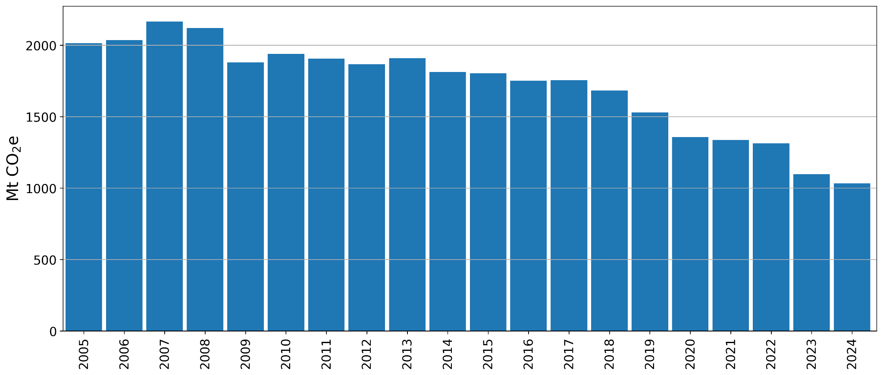
Source: European Environment Agency, EU Emissions Trading System (ETS) data viewer. Notes: All Countries, 20-45 & 99 All stationary installations, 2 Verified emissions.

Why Cap-and-Trade Instead of a Carbon Tax?
Carbon pricing can be implemented in two main ways: carbon taxes or cap-and-trade systems.
A carbon tax fixes the price of emissions while allowing the quantity of emissions to adjust (you can read more about this in our article Carbon Taxes: A Libertarian’s First Love).
A cap-and-trade system does the opposite: it fixes the quantity of emissions and allows the market to determine the price.
Both approaches can reduce emissions, but cap-and-trade offered several advantages in the European context:
- First, the EU’s institutional structure made carbon taxation difficult. Tax policy requires unanimous approval from all Member States, which is a high political hurdle. By contrast, cap-and-trade could be adopted through environmental legislation with qualified majority voting.
- Second, a quantity-based system ensured that the EU could guarantee emissions reductions consistent with international commitments, particularly those under the Kyoto Protocol.
- Finally, the trade aspect was more acceptable to industry. Firms were often willing to engage with a market-based mechanism that rewarded efficiency, particularly when it allowed flexibility in how emissions reductions were achieved.
In economic terms, the choice reflects a trade-off between price certainty and emissions certainty. Carbon taxes fix the price but leave emissions uncertain. Cap-and-trade fixes emissions but allows prices to fluctuate.

The Four Phases of the EU ETS
The EU ETS has evolved through four phases, each reflecting lessons learned and as the system developed:
- Phase 1 (2005-2007): Pilot phase.
- Phase 2 (2008-2012): Aligning with the Kyoto Protocol.
- Phase 3 (2013-2020): Centralisation and auctioning.
- Phase 4 (2021-present): Strengthening the system.
Before discussing each phase in detail, EU ETS prices and phases are shown in the figure below.
Figure - Auctioned Emissions Allowances Prices Over Time (€ / tCO₂)
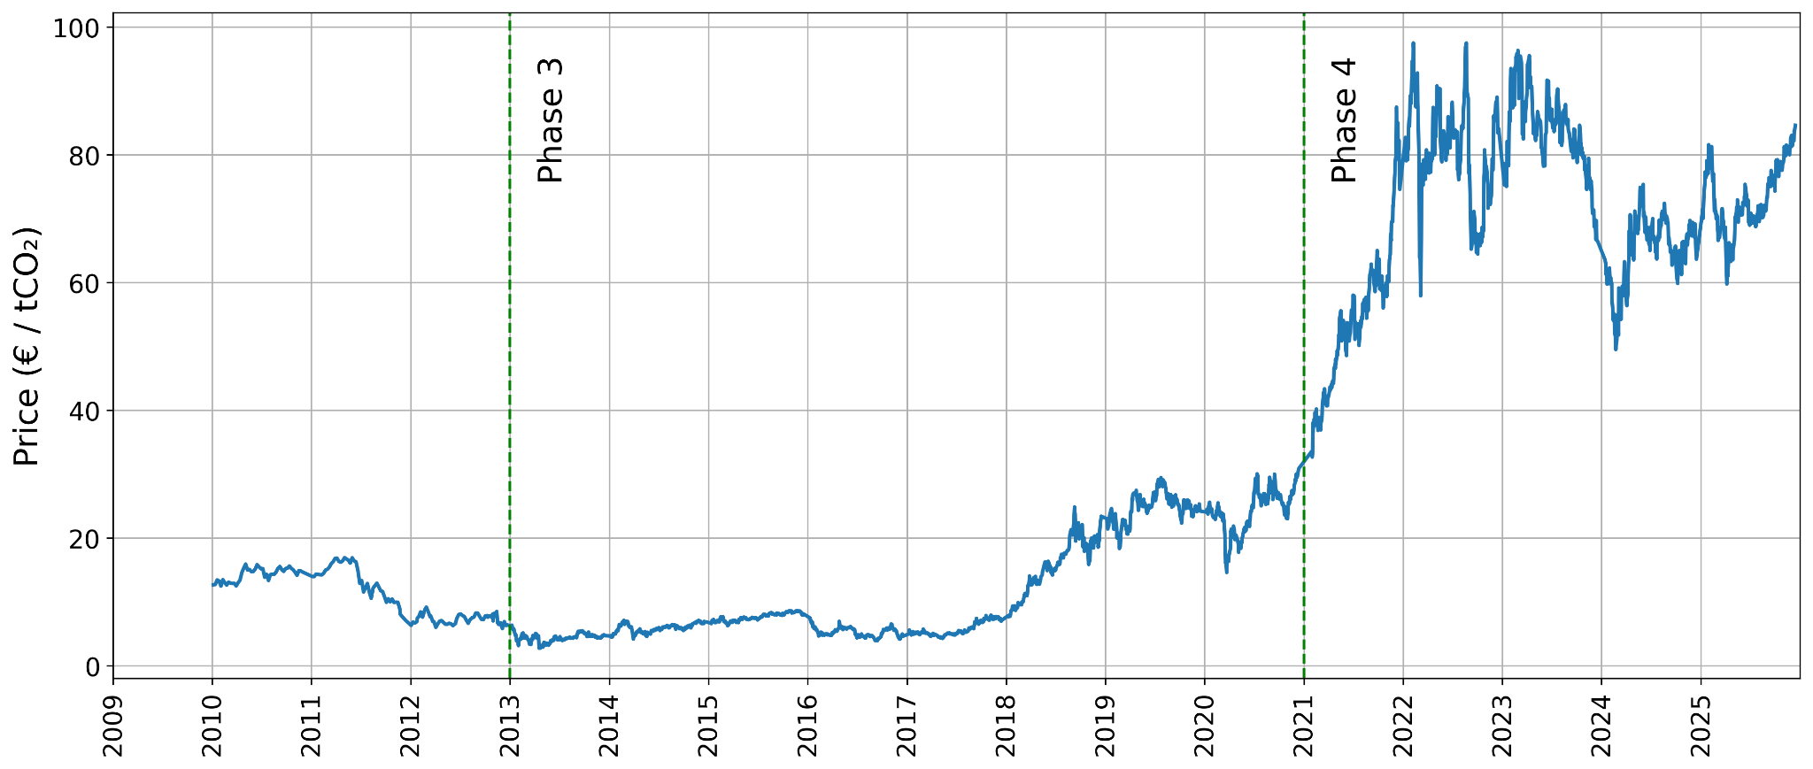
Source: International Carbon Action Partnership Allowance Price Explorer and EU ETS Factsheet. Note only auction (“primary”) prices are shown.

Phase 1 (2005–2007): The pilot phase
The EU began cautiously. An important early design choice was to start where emissions are easiest to measure.
Monitoring, reporting and verification (MRV), though rarely glamorous, is essential for any carbon market. Before a market can function, emissions must be measured reliably and independently verified. The EU therefore initially focused on the power sector and heavy industry, where emissions can be monitored through fuel use and industrial processes.
Most allowances were allocated for free to firms based on historical emissions. The priority was not yet strict emissions reductions but building the administrative infrastructure required for a functioning carbon market.
Allowances from Phase 1 could not be banked into later phases. When emissions data were finally published in 2006, it became clear that too many allowances had been issued. The market realised the cap was not binding, and carbon prices quickly collapsed.
The episode illustrated a simple economic principle: when allowances are abundant, their price falls toward zero. Only when the cap creates genuine scarcity does a meaningful carbon price emerge.
Despite this setback, Phase 1 successfully established the institutional foundations of the carbon market.

Phase 2 (2008–2012): Aligning with the Kyoto framework
Phase 2 coincided with the first commitment period under the Kyoto Protocol.
By this stage policymakers had a clearer understanding of emissions levels across sectors. Banking of allowances was introduced, allowing companies to carry unused permits into future periods, thereby smoothing the cost of complying over time and linking current carbon prices to expectations about future policy.
Even at relatively modest prices, often between €5 to €20 per tonne, the EU ETS began to influence operational decisions, particularly in electricity markets. Carbon prices altered the relative operating costs of coal and gas plants, encouraging switching at the margin. Much of the early emissions reduction in EU ETS sectors came from this switching.
Economically, the carbon price acts like an additional input cost. When carbon prices rise, technologies that emit more CO₂ become relatively more expensive, encouraging shifts towards cleaner alternatives.
However, the Global Financial Crisis caused a sharp drop in economic activity and industrial output. Emissions fell, but largely because of the recession rather than the carbon price itself. The resulting surplus of allowances pushed prices down and weakened incentives to decarbonise.
Debate during this phase increasingly focused on the level of the cap and the allocation of permits. Member States determined how allowances were distributed across sectors and installations through national allocation plans, which led to extensive negotiations over how the overall emissions cap should be shared across industries.

Phase 3 (2013–2020): Centralisation and auctioning
Phase 3 introduced major structural reforms.
Free allocation was largely phased out for the power sector, which does not face international competition and had been passing the additional cost of allowances into electricity prices.
Instead, most allowances began to be auctioned through a common European platform, operated by the European Energy Exchange (EEX) in Leipzig. As the figure below shows, from the start of this phase, auctioned allowances began to account for a larger share of the total.
Economically, the shift mattered mainly for the distribution of costs rather than the efficiency of the system. Even when allowances are allocated for free, firms still face an opportunity cost when using them, because they could have sold them instead. In effect, emitting an additional tonne of CO₂ requires giving up the market value of an allowance. This means the carbon price continues to shape operational and investment decisions regardless of how permits are initially allocated.
Figure - Emissions Allowances Over Time (Mt CO₂e)
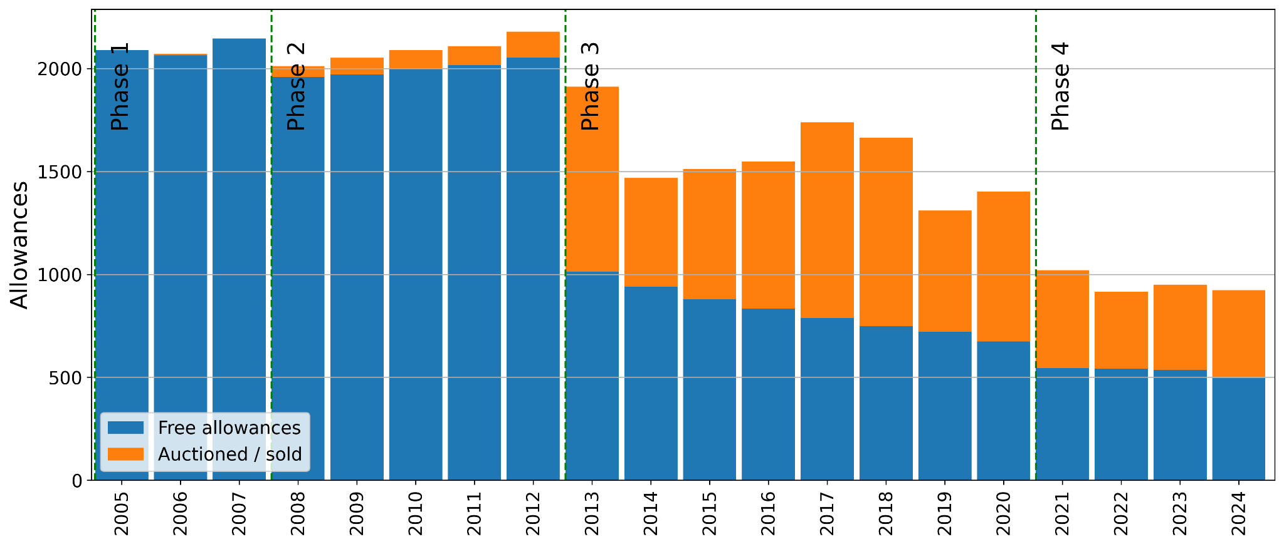
Source: European Environment Agency, EU Emissions Trading System (ETS) data viewer. Notes: All Countries, 20-45 & 99 All stationary installations, 1.1 Freely allocated allowances and 1.3 Allowances auctioned or sold (EUAs and EUAAs).
By the mid-2010s, however, the surplus of unused allowances had grown to billions of tonnes. This surplus partly reflected the decline in emissions after the Global Financial Crisis and the continued issuance of allowances under earlier rules. To address this, the EU introduced the Market Stability Reserve (MSR), a mechanism designed to stabalise the carbon market.
The MSR does not confiscate allowances that firms already hold. Instead, it adjusts the number of allowances entering the market through future auctions. When the number of unused allowances circulating in the market becomes too large, a portion of future allowances is automatically withheld from auction and placed in the reserve. If later supply becomes tight, allowances can be released back into the market. In this way, the MSR helps prevent large surpluses from suppressing carbon prices for long periods.
Auction revenues also became an important policy tool. A portion of these funds were directed to initiatives such as the Innovation Fund, supporting low-carbon technologies, and the Modernisation Fund, helping lower-income Member States support their energy transitions.
At the same time, decision-making shifted increasingly from national governments to EU-level institutions. As mentioned, earlier phases relied on national allocation plans. During Phase 3 this was replaced with a single EU-wide cap, common allocation rules, and a centralised platform. These reforms reduced fragmentation between national systems and strengthened the integration of the European carbon market.

Phase 4 (2021–present): Strengthening the system
Phase 4 reflects the EU’s more ambitious climate goals under the European Green Deal.
The EU has committed to reducing greenhouse gas emissions by at least 55% by 2030 compared with 1990 levels and to achieving climate neutrality by 2050. The aim is to use the EU ETS cap to help deliver these targets.
As a result, the ETS cap on emissions is now declining faster, tightening the supply of allowances and strengthening the carbon price signal.
Carbon prices rose sharply in the early years of Phase 4, reaching close to €100 per tonne in 2022 (see figure above). Prices subsequently fell to around €50 before recovering. This reflected several factors, including lower demand for allowances during the energy crisis and a temporary increase in the number of allowances auctioned as part of EU measures such as the REPowerEU programme.
Some commentators characterised this trough as a market collapse. A more measured interpretation is that the system is still maturing. Carbon prices fall when demand for allowances weakens or when additional supply enters the market. Economic cycles, energy price shocks, and weather conditions all influence economic activity and energy demand, which in turn affect emissions and therefore the demand for allowances.
Price volatility therefore reflects the market responding to changing economic conditions. What matters is that the carbon price remains embedded in investment decisions across Europe’s energy and industrial sectors.
Since this phase, Member States are also expected to use a significant share of auction revenues for climate-related investments such as renewable energy and building insulation.

The Future of The Carbon Market
The EU ETS has already driven many of the lowest-cost emissions reductions, particularly in electricity generation.
The next stage will likely be more difficult. Future decarbonisation will increasingly depend on transforming hard-to-abate industrial sectors, where alternatives to fossil fuels remain expensive.
European policy is evolving to address this challenge. Two developments are particularly significant:
- The EU ETS 2 will extend carbon pricing to buildings and road transport, bringing these sectors into the EU’s broader carbon pricing framework.
- The Carbon Border Adjustment Mechanism (CBAM) will apply a carbon price to imported goods based on their emissions. Its goal is to prevent leakage - where production, and therefore emissions, move to jurisdictions with weaker climate policies - and to address competitiveness concerns by ensuring that European firms face similar carbon costs to foreign producers selling into the EU market.
Together these reforms reflect a broader shift in European climate policy: expanding carbon pricing beyond the sectors where emissions were easiest to measure, toward covering a larger share of the economy’s emissions.
As the cap tightens further, however, the system will face an important institutional test. Scarcer allowances will tend to push carbon prices higher, increasing pressure on carbon-intensive industries. In such circumstances, there may be political or industrial demands to slow the decline of the cap.
Maintaining the credibility of the system will therefore depend on whether policymakers sustain the long-term emissions trajectory despite short-term economic pressures. As the experience of the past two decades shows, strong governance and clear rules are essential for maintaining confidence in the carbon market. Instruments such as the CBAM partly address this challenge by reducing competitiveness concerns that could otherwise weaken support for a strong carbon price.

Summary
Over two decades, the EU ETS has evolved from a cautious pilot programme into the central pillar of European climate policy.
By placing a price on carbon and allowing markets to identify the cheapest reductions, it has delivered significant emissions cuts while maintaining flexibility for industry.
But the system continues to evolve. As Europe tackles harder-to-abate sectors and expands carbon pricing to new parts of the economy, the ETS will increasingly interact with other policy instruments designed to support industrial decarbonisation and maintain political support for a rising carbon price.
One of the most important of these is the CBAM, which aims to address the leakage and competitiveness challenges that carbon pricing can create as the cap tightens and allowances become scarcer.
How these policies interact will play an important role in determining whether the EU ETS can sustain its long-term emissions trajectory. That will be the subject of a forthcoming article.

The sectors covered tend to emit carbon dioxide, nitrous oxide, and perfluorocarbons. As such, methane is not directly regulated under the EU ETS. Methane emissions in Europe arise mainly from agriculture, waste, and fossil fuel production: sectors that fall largely outside the ETS. For this reason, methane is generally addressed through separate regulatory instruments, such as leak detection requirements in oil and gas infrastructure, rather than through the carbon market.
Theoretically, a correctly set carbon tax would also guarantee emissions reductions consistent with these international commitments. However, practical issues leading to the underestimation of the correct level could result in missing international commitments.
Gas-fired generation emits roughly half as much carbon dioxide as coal, meaning that even modest carbon prices could influence which plants were dispatched.
Additional supply also came from international carbon credits issued under the Kyoto Protocol, which could be used for compliance within the EU ETS during this period.
From 2021 to 2023, the cap reduced by 2.2% each year, increasing to 4.3% each year between 2024 to 2027. From 2028 onwards, it will decrease by 4.4% per year. See EU ETS Factsheet.
The proposed Clean Industrial Deal aims to support the decarbonisation of heavy industry, while new policy instruments are being introduced alongside the ETS.

